Consider the Country table and Persons table that you created earlier and perform the following: (1)Perform inner join, Left join, and Right join on the tables.

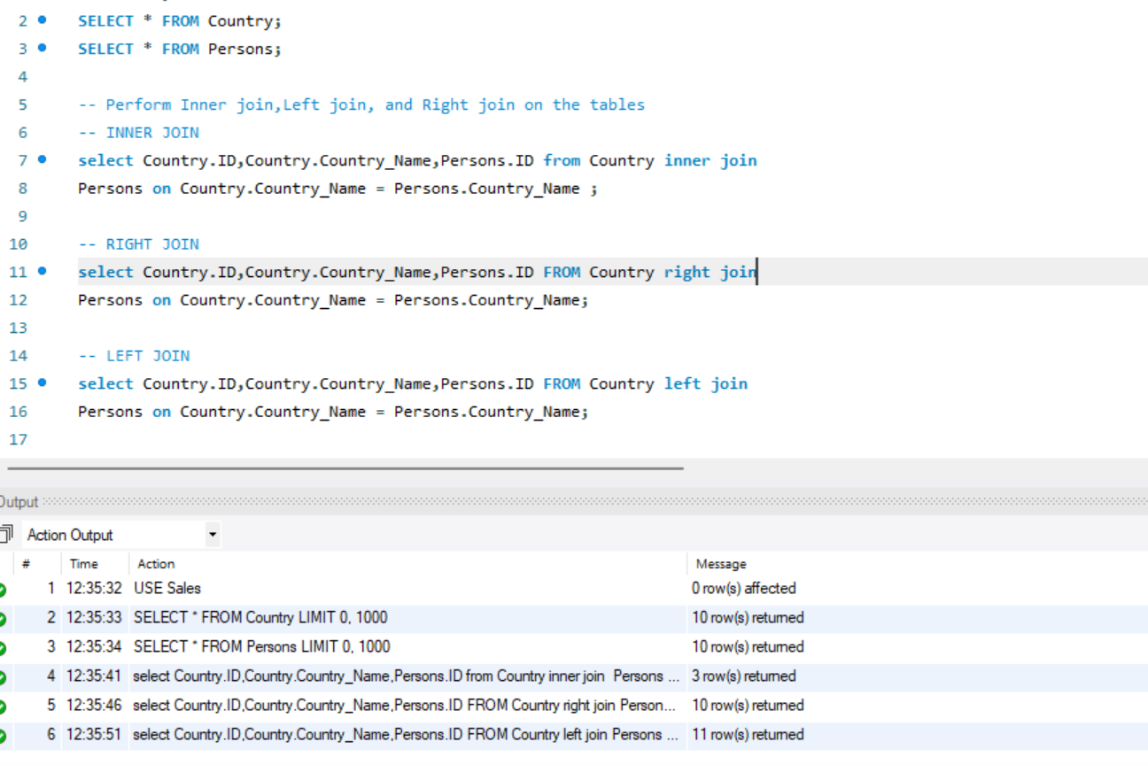

(2)List all distinct country names from both the Country and Persons tables

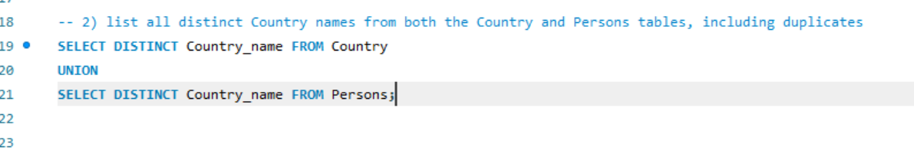

(3)List all country names from both the Country and Persons tables, including duplicates.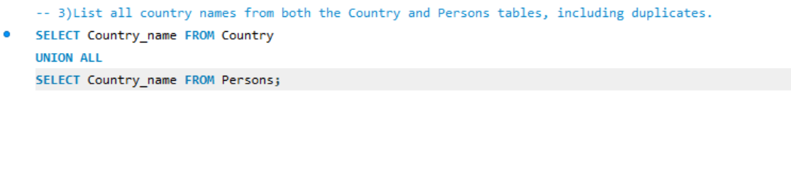

(4)Round the ratings of all persons to the nearest integer in the Persons table.

